Name____________________________________________________________________ Date____________

Module Assessment Review
UR (UNDERSTAND RATES)
- Use the tables below to answer a-c.
Celebration Cinema
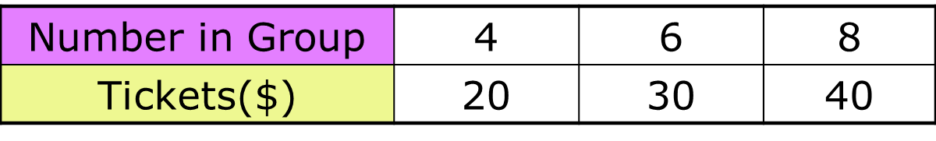
NCG
Number in Group | 5 | 10 | 15
Tickets ($) | 27.50 | 55

- Find the missing values in the two tables above. (UR)

- Write how much each cinema charges as a rate. (UR)

- Who charges more per ticket? Justify your answer. (UR)

SR (SOLVE RATE PROBLEMS)
- Your family takes a trip to Lake Michigan. Your mom drives 120 minutes at a constant speed of 50 miles per hour. She reaches a traffic jam and slows down to drive for another 30 minutes at constant speed of 20 miles per hour.

- How far did you and your family travel altogether?

- Meijer is selling two brands of socks:
Brand A -3 pair of socks for $7.35
Brand B- 5 pair of socks for $12.00

- What are the rates that Brand A and Brand B are selling for?

- Which brand is the better buy?

UP (UNDERSTAND PERCENT)
- Complete the table below by filling in missing values.
Fraction | Decimal | Percent | Ratio
 | 0.07
 |  | 45%
 |  |  | 3:4

- What percent does the grey portion of the following model represent?

SP (SOLVE PERCENT PROBLEMS)
- Katie likes to run. She ran 6 miles before school this morning. This is only 60% of the total miles she will run for the day. How many miles does she run in one day?

- Mason has read 75% of his book for Mrs. Thelen’s class. The book is 320 pages long. How many pages has he read?

- Complete the following table. (SP)

ITEM | ORIGINAL  PRICE | SALE PRICE | AMOUNT OF DISCOUNT | PERCENT SAVED | PERCENT PAID
Soccer ball |  |  | $3 | 15%
iPhone |  |  | $40 |  | 90%
Nike Shoes | $120 | $90

