Name______________________________________________________________________________
Ratio Tables Practice
Use the ratio table to find equivalent ratios.
- Several groups of friends are purchasing tickets to an amusement park. The table shows how much the different groups will pay in all.
  - Determine how much a group of 7 friends will pay.
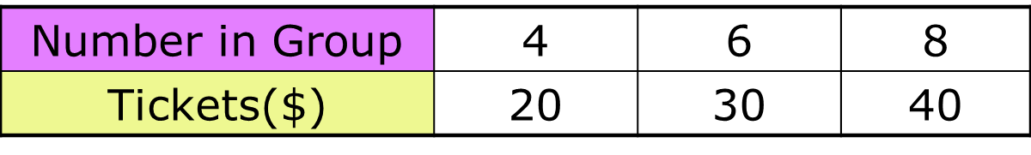
  - Determine how much a group of 11 friends will pay.

- Fred is saving for a new sound system. The table shows some of the amounts he has saved in different numbers of weeks.
  - Determine how many weeks it will take Fred to save $270.

  - Determine how much Fred will have saved after 10 weeks.

Savings ($) | $135 | $225 | $405
# of weeks | 3 weeks | 5 weeks | 9 weeks

Create a ratio table to organize and find equivalent ratios.

- Create a ratio table to answer the following question.
It takes 48 chicken fingers to feed Mrs. Smith’s 6th grade class of 20 students. How many chicken fingers would be needed for 30 students?

Label:

Label:

