Name____________________________________________ Date_____________

Area & Surface Area Practice

Find the area of each figure. Please show your work!

[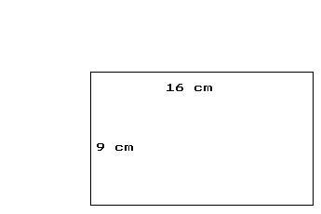](http://www.google.com/url?sa=i&rct=j&q=rectangle&source=images&cd=&cad=rja&docid=CCPRyW5gMHKG-M&tbnid=P0c4wLMgc1XG8M:&ved=0CAUQjRw&url=http://math.tutorvista.com/geometry/rectangle.html&ei=WrN-UYXPM8nV2QXn7IDIAQ&psig=AFQjCNFK4QbUpLN3axNfKhjA9cuMwuoQxA&ust=1367344325889426) [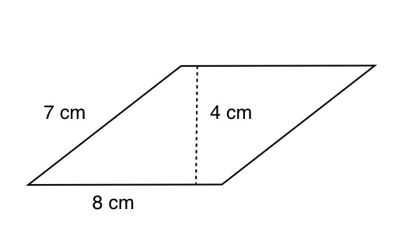](http://www.google.com/url?sa=i&rct=j&q=parallelogram+area&source=images&cd=&cad=rja&docid=0EsZuwiSSX2JHM&tbnid=VhIOa-bePAGDpM:&ved=0CAUQjRw&url=http://www.proprofs.com/quiz-school/story.php?title%3Darea-perimeter-rectangles-triangles-parallelograms&ei=k7N-UevHIcTu2wX0rIC4BA&psig=AFQjCNEJz65f9wDEm-mRKH6W4U0l60t2Kg&ust=1367344396010145) [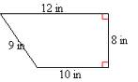](http://www.google.com/url?sa=i&rct=j&q=trapezoid+area&source=images&cd=&cad=rja&docid=eyHvIxUfX8bf2M&tbnid=0z10N4IP9DfQMM:&ved=0CAUQjRw&url=http://online.missouri.edu/exec/data/courses2/8242/lesson01/lesson01.xht&ei=C7R-Ubi2IMy_2QWD9IDICw&psig=AFQjCNG1Gtg-ZO26GwkRkdPtQupvrZlLjg&ust=1367344492799908)

Find the surface area of each figure. SHOW YOUR WORK!

[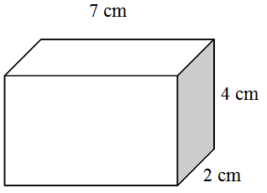](http://www.google.com/url?sa=i&rct=j&q=rectangular+prism+surface+area&source=images&cd=&cad=rja&docid=1qudDT35SPA_rM&tbnid=VFNuHm4LkvTHsM:&ved=0CAUQjRw&url=http://www.pdesas.org/module/content/resources/6173/view.ashx&ei=gbR-UceTMrLE2QXhx4DoCA&psig=AFQjCNHCpHHCEEFHofqFJp--Ir0BEvqcMQ&ust=1367344632961815) [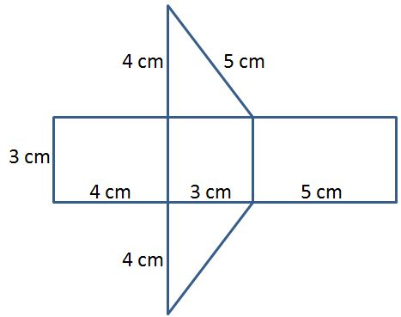](http://www.google.com/url?sa=i&rct=j&q=triangular+prism+net+surface+area&source=images&cd=&cad=rja&docid=YBfFfhxzsKwItM&tbnid=aGm3AG88Eoej0M:&ved=0CAUQjRw&url=http://scimathmn.org/stemtc/frameworks/631a-measurement-polygons-prisms&ei=tLR-UaG-Koiv2QWHlICYCg&psig=AFQjCNFwoaFZUCUewm3s6DYfxiShyCSKVA&ust=1367344669280387)

[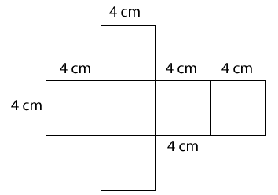](http://www.google.com/url?sa=i&rct=j&q=rectangular+prism+net+surface+area&source=images&cd=&cad=rja&docid=09jPNzLYkIO_tM&tbnid=1sQYuO4VI_sCkM:&ved=0CAUQjRw&url=http://www.nwsd.ca/mathstreet/HTML/gr6Sasses4m.htm&ei=RrV-UbD9LKLy2QXm2YC4Dg&psig=AFQjCNGmgyblHF3Iuh1iWmelTpuBBz85ng&ust=1367344791070892)